**Practical 1**

**Aim:** Introduction to Excel

1. Create a data set
2. Sort data
3. Apply filter
4. Write formula
5. Remove duplicate

**Name:** Ashutosh Ganesh Mhatre

**Class:** FYBSc.CS [B]

**Roll No:** (08)

**Subject:** Descriptive Statistics

**Sign:**

**Introduction to Excel**

1. Create a dataset
2. Sort Data : Step i) Select the entire table

ii) Go to Data tab → Sort→ Sort by Department (A-Z)→

ok

1. Apply Filter : Step i) Select header row.
   1. Go to data tab→ Filter
   2. Click on the dropdown in “Department” and select only science .
2. Write Formulas : i) Total

Sum→= sum(Number1,Number2, ) i,e select range

* 1. Average →= Average (Number1,Number2, ) i.e

select range.

* 1. Result → =if(logical_test,”pass”,”false”) or

=if(logical_test,”true”,”false”)

1. Remove Duplicates: Step i) Copy Department column→Data tab →

Remove Duplicates → select Department →OK

**Output:**

**1.**

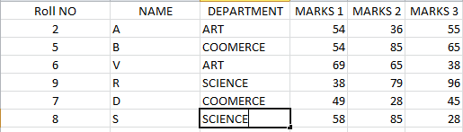

**2.**

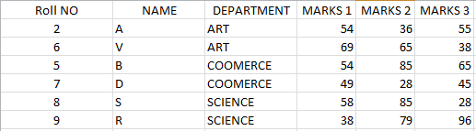

**3.**



**4**

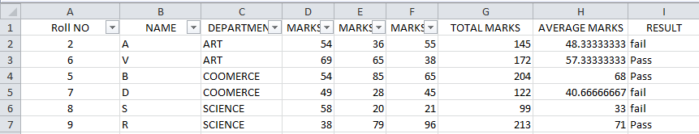

**5.**

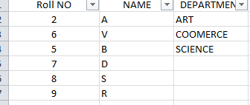

**PRACTICAL 2**

**Aim:** Data Entry & Manipulation

1. Create data Set
2. Text to column
3. Transpose data
4. Pivot table

**Name:** Tejas D. kadu

**Class:** FYBSc.CS [B]

**Roll No:** 63

**Subject:** Descriptive Statistics

**Sign:**

**Data Entry and Manipulation**

1. Create a dataset

2) Text-to-Columns: Step: i) Select the entire table

                                           ii)Go to Data  tab  → Text-to-Columns → Delimited

                                          iii)→Next →Comma → Finish.

3) Transpose Data: Step : i)  Copy the table → Go to a new sheet → Right-click → Paste Special → Transpose.

4) Pivot Table: Step : i) Go to the Insert tab on the Ribbon. → Click Pivot →Table In the dialog box: selecte the data range  In the dialog box: selecte the data range  Choose whether you want the Pivot Table in (New Worksheet or the Existing Worksheet)  → Click OK. →  (We want to summarize total sales by Department   )

Using Following Table

|  |  |  |
| --- | --- | --- |
| Name | Department | Sales |
|  |
| John | A | 200 |  |
| Priya | B | 300 |  |
| Ravi | A | 150 |  |
| Meera | B | 250 |  |
| Anil | A | 100 |  |
| Neha | B | 350 |  |

**Output:-**

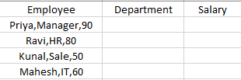

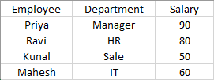





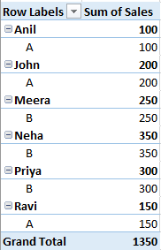

**PRACTICAL NO: 03**

**Aim:** Data Validation in Excel

1. Specify a valid range of value for cell
2. Specify a valid List of value for cell
3. Specify a valid birth of value for cell

**Name:** Ashutosh Ganesh Mhatre

**Class:** FYBSc.CS [B]

**Roll No:** (08)

**Subject:** Descriptive Statistics

**Sign:**

**Use:i) Stop: Prevents entry of invalid data (default)**

**ii)** **Reduces errors in calculations and decision-making**

We will create a simple dataset of student names and their marks in a subject.

We want:

1. **Marks must be between 0 and 100** : Step :i)  select the Marks column → Go to the Data tab → Data Validation → Data Validation…
2. In the dialog box →setting →Under Allow, select Whole number (or Decimal if you want to allow decimals). →Under Data, select between. →Enter Minimum = 0, Maximum = 100.
3. Click OK.

* **Set Error Alerts:** Select the cell →  Go to **Data** → **Data Validation** → **Error Alert** tab.

Choose:

1. **Style:** Stop / Warning / Information
2. **Title:** (Optional – Appears in the error box)
3. **Error Message:** (E.g., "Please enter a number between 1 and 100")

 Click OK.

2**. Grade can only be chosen from a fixed list**: A, B, C, D, F. Step:i)  Select the Grade column

→ Go to the Data tab → Data Validation → Data Validation…

ii)  In the dialog box  →setting →Under Allow, select List. In the Source box, type: A,B,C,D,F

iii)Click OK.

* **Set Error Alerts:** Select the cell →  Go to **Data** → **Data Validation** → **Error Alert** tab.

Choose:

**Style:** Stop / Warning / Information

**Title:** (Optional – Appears in the error box)

**Error Message:** (E.g., " Please select a valid  from the list: A, B,C,D.")

 Click OK.

**3. Date of Brith** **only be chosen from a fixed Date:** Step:i)  Select Date of Brith the  column

→ Go to the Data tab → Data Validation → Data Validation…

1. In the dialog box  →setting →Under Allow, select Date. →Under Data, select between. →start Date = 01/01/2006, End date= 01/01/2008.
2. Click OK.

* **Set Error Alerts:** Select the cell →  Go to **Data** → **Data Validation** → **Error Alert** tab.

Choose:

**Style:** Stop / Warning / Information

**Title:** (Optional – Appears in the error box)

**Error Message:** (E.g. " Only dates between Jan 1, 2006 and Dec 31, 2008 are allowed.

.")

 Click OK.

**Output:**

**1)**

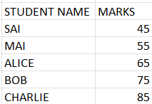

**2)**

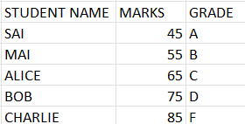

**3)**

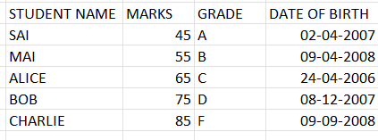

**PRACTICAL NO: 04**

**Aim: Diagram and Graph**

**1. Excel Program to plot Bar Chart**

|  |  |  |
| --- | --- | --- |
| **Name** | **Maths** | **Science** |
| KOMAL | 56 | 67 |
| ASHITA | 53 | 73 |
| KISAN | 67 | 49 |
| YUKTI | 52 | 63 |
| SAVALI | 49 | 56 |
| DIVYANSH | 71 | 64 |

**2. Excel Program to plot Histogram**

|  |  |
| --- | --- |
| **STUDENT** | **marks** |
| **A** | **19** |
| **B** | **53** |
| **C** | **23** |
| **D** | **75** |
| **E** | **34** |
| **F** | **57** |
| **G** | **72** |
| **H** | **49** |
| **I** | **43** |
| **J** | **39** |
| **K** | **41** |
| **L** | **68** |
| **M** | **48** |
| **N** | **26** |

**3. Excel Program to plot pie Chart Using the data of Bar chart – Add a Total Column to your table in excel < Use the Name and Column and the total Column to Make a pie chart**

**4. Boxplot 12,45,65,85,45,47,23,26,24,12,11,54,56,47,36,45,4**

**Name:** Ashutosh Ganesh Mhatre

**Class:** FYBSc.CS [B]

**Roll No:** (08)

**Subject:** Descriptive Statistics

**Sign:**

**Output:**

**1.**

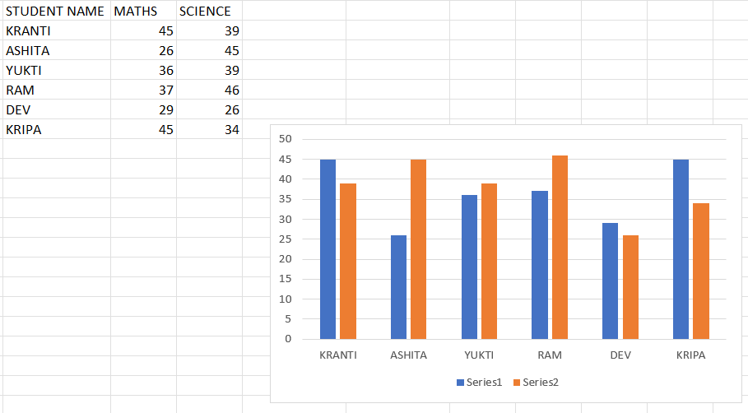

**2.**

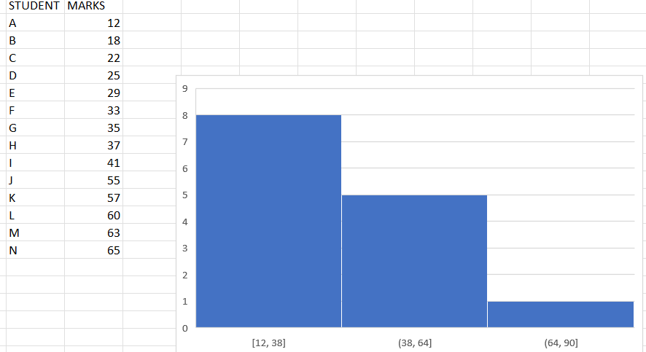

**3.**

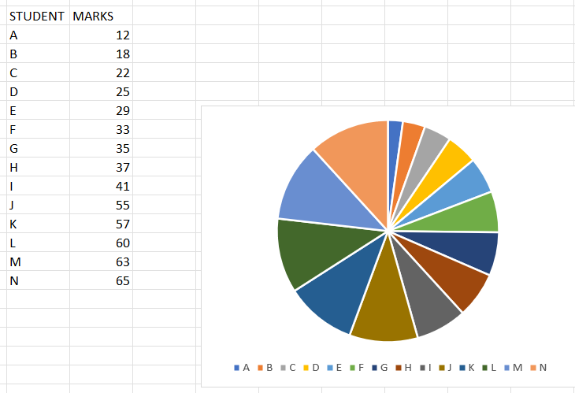

**4.**

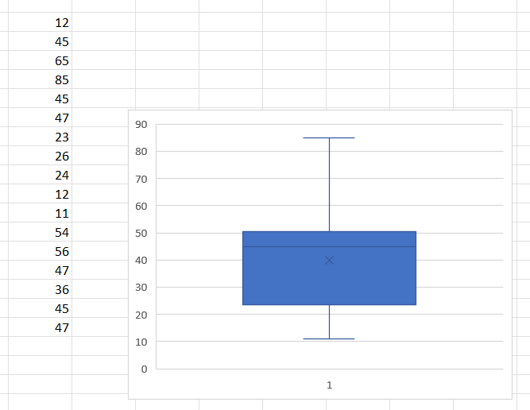

**PRACTICAL NO: 05**

**Aim: Measure of central tendency**

**1. Calculate Mean, Median and Mode for the following data**

**a) 15,16,18,19,20,24**

**b) 45,48,47,43,42**

**c)100,105,115,115,1062.**

**2. Find Mean**

|  |  |
| --- | --- |
| **CLASS INTERVAL** | **FREQUENCY** |
| **1** | **100** |
| **2** | **104** |
| **3** | **136** |
| **4** | **107** |
| **5** | **101** |
| **6** | **103** |
| **7** | **105** |

**3.FIND MEDIAN AND MODE**

|  |  |
| --- | --- |
| **CLASS INTERVAL** | **FREQUENCY** |
| **0-100** | **13** |
| **100-200** | **18** |
| **200-300** | **27** |
| **300-400** | **34** |
| **400-500** | **23** |
| **500-600** | **17** |
| **600-700** | **10** |

**Name:** Ashutosh Ganesh Mhatre

**Class:** FYBSc.CS [B]

**Roll No:** (08)

**Subject:** Descriptive Statistics

**Sign:**

**Output:**

**1.**

i)

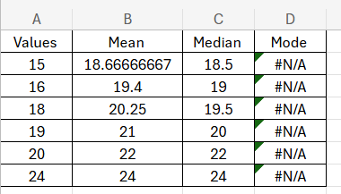

ii)

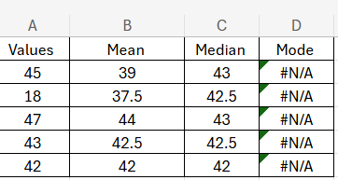

iii)

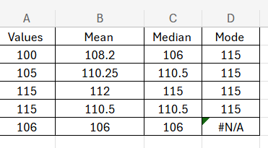

2

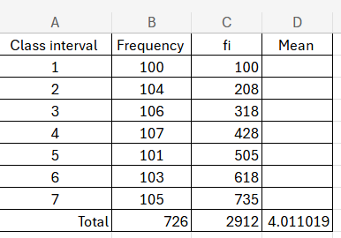

3

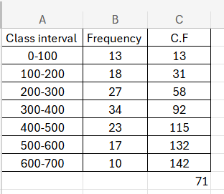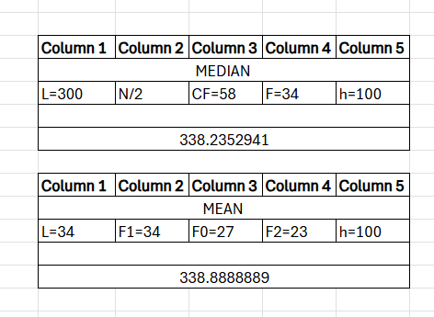

**PRACTICAL NO: 06**

**Aim: Measures of Dispersion**

**Calculate Range, Interquartile rang, variance, Standard Deviation, Skewness and Kurtosis**

|  |  |
| --- | --- |
| **Student Name** | **Marks** |
| **A** | **45** |
| **B** | **52** |
| **C** | **50** |
| **D** | **60** |
| **E** | **65** |
| **F** | **70** |
| **G** | **75** |
| **H** | **80** |
| **I** | **85** |
| **J** | **90** |
| **K** | **78** |
| **L** | **65** |
| **M** | **95** |
| **N** | **65** |
| **O** | **46** |
| **P** | **59** |
| **Q** | **84** |
| **R** | **61** |
| **S** | **95** |
| **T** | **86** |
|  |  |
| **List of things** | **price** |
| **Book** | **58** |
| **Pen** | **65** |
| **pencil** | **48** |
| **Calculator** | **52** |
| **Highlighter** | **43** |

**Name:** Ashutosh Ganesh Mhatre

**Class:** FYBSc.CS [B]

**Roll No:** (08)

**Subject:** Descriptive Statistics

**Sign:**

**Output:**

**1**

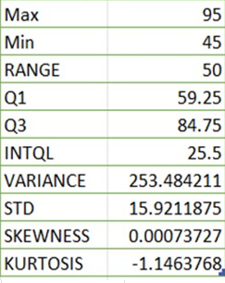

2

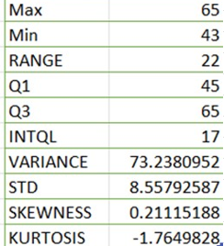

**Practical 7**

**Aim : Correlation**

1. 2.

|  |  |
| --- | --- |
| *Study Hours* | *Test Score* |
| 2 | 30 |
| 3 | 40 |
| 4 | 50 |
| 5 | 60 |
| 6 | 70 |
| 7 | 80 |

|  |  |
| --- | --- |
| Study Hours | Stress Level |
| 2 | 80 |
| 3 | 70 |
| 4 | 60 |
| 5 | 50 |
| 6 | 40 |
| 7 | 30 |

3.

|  |  |
| --- | --- |
| Study Hours | Random |
| 2 | 55 |
| 3 | 60 |
| 4 | 48 |
| 5 | 75 |
| 6 | 53 |
| 7 | 64 |

**Name:** Ashutosh Ganesh Mhatre

**Class:** FYBSc.CS [B]

**Roll No:** (08)

**Subject:** Descriptive Statistics

**Sign:**

**Formula : Correlation : =CORREL(array1,array2)**

**Output**

1)

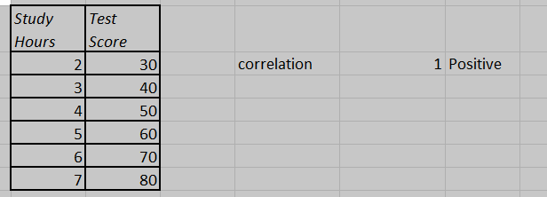

2)

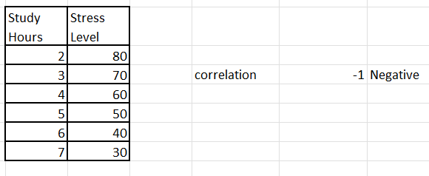

3)

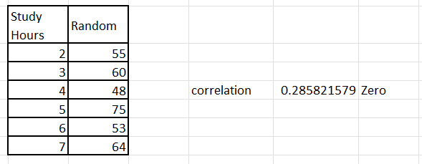

**Practical : 8**

**Aim: Regression**

Q1. Calculate the Slopes , y  intercept  and the regression line

|  |  |  |  |  |  |  |  |  |  |  |
| --- | --- | --- | --- | --- | --- | --- | --- | --- | --- | --- |
| X | 1 | 2 | 3 | 4 | 5 | 6 | 7 | 8 | 9 | 10 |
| y | 1.59 | 2.87 | 4.15 | 5.33 | 6.61 | 7.99 | 9.02 | 10.31 | 11.75 | 13.12 |

Q2. Calculate the Slopes , y  intercept  and the polynomial regression

|  |  |  |  |  |  |  |  |  |  |  |
| --- | --- | --- | --- | --- | --- | --- | --- | --- | --- | --- |
| X | 1 | 2 | 3 | 4 | 5 | 6 | 7 | 8 | 9 | 10 |
| y | 3.2 | 4.9 | 7.1 | 8 | 10.3 | 11.6 | 13.8 | 15.4 | 17.2 | 18.7 |

**Name:** Ashutosh Ganesh Mhatre

**Class:** FYBSc.CS [B]

**Roll No:** (08)

**Subject:** Descriptive Statistics

**Sign:**

**Output**

1)

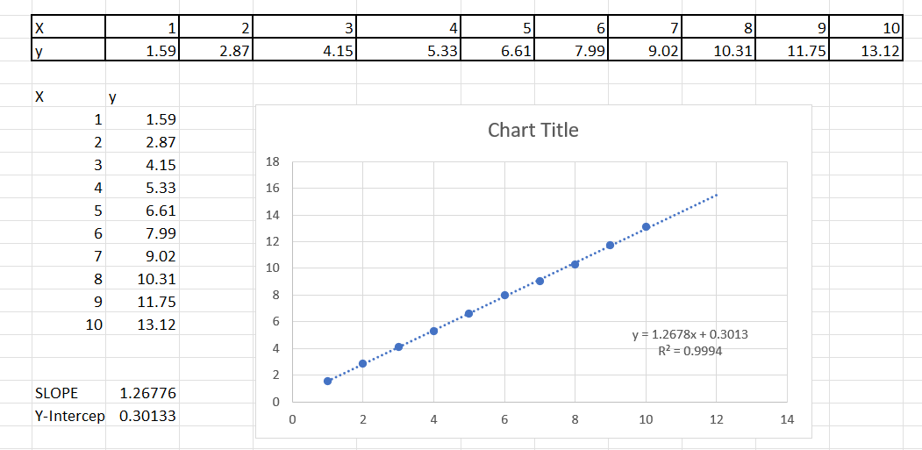

2)

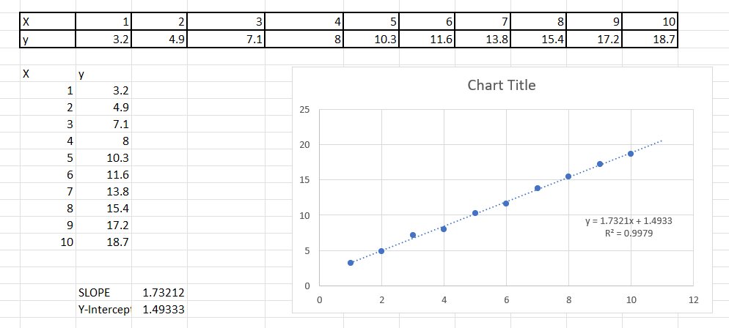

**Practical:9**

Regression – 2

1. Multiple Linear Regression in Excel

|  |  |  |
| --- | --- | --- |
| Y | X1 | X2 |
| 3.1 | 1 | 5.2 |
| 6 | 2 | 6.8 |
| 8.7 | 3 | 7 |
| 7.9 | 4 | 9.1 |
| 9.8 | 5 | 8.5 |
| 12.2 | 6 | 11 |
| 11.6 | 7 | 12.4 |
| 14.7 | 8 | 13.5 |
| 15.9 | 9 | 14.2 |
| 17.5 | 10 | 15 |

Load Analysis ToolPak

Go to File → Options → Add-ins → Analysis ToolPak → Go → Check → OK.

* Go to Data → Data Analysis → Regression.
* Input **Y Range** (dependent variable).
* Input **X Range** (all independent variables).
* Select output range → Click **OK**.

**Name:** Ashutosh Ganesh Mhatre

**Class:** FYBSc.CS [B]

**Roll No:** (08)

**Subject:** Descriptive Statistics

**Sign:**

**Output**

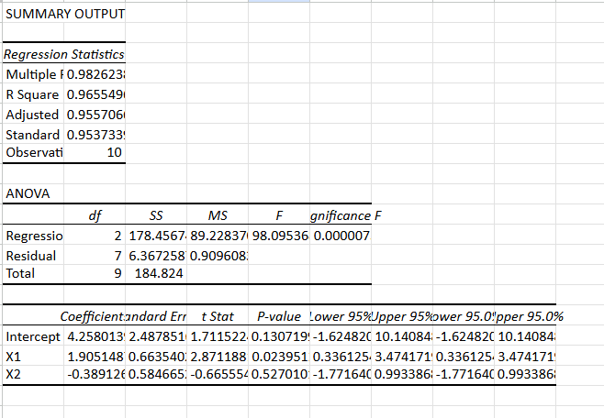

**PRACTICAL NO: 10**

**Aim: Designing a survey form collect primary data and analyse**

**Age (Number)**

**Gender (Male/female/other)**

**Satisfaction (1 to 5)**

**Monthly Spend (in Rs)**

**Feature (price/ quality/ service / location)**

**Recommend(yes/no)**

**(Ask your friends to answer)**

|  |  |  |  |  |  |
| --- | --- | --- | --- | --- | --- |
| **Age** | **Gender** | **satisfaction** | **Monthly spend** | **feature** | **Recommendation** |
|  |  |  |  |  |  |
|  |  |  |  |  |  |
|  |  |  |  |  |  |
|  |  |  |  |  |  |
|  |  |  |  |  |  |

**Find 1. Mean Age**

**2 Median Satisfactions**

**3.Max Spend**

**4.Bar chart for Age**

**5. Line regression (satisfaction and Monthly Spend) (find m & c and regressions line)**

**Name:** Ashutosh Ganesh Mhatre

**Class:** FYBSc.CS [B]

**Roll No:** (08)

**Subject:** Descriptive Statistics

**Sign:**

**Output**

